**8086 EMULATOR**

**LAB 07**

**SUBMITTED BY:** **:** Hafsah tahir

Sawaira saeed

Rabia batool

**ROLL NO:** 2022-BSE-052,64,67

**SUBMITTED TO:** ENGR.SHOAIB

**COMPUTER ARCHITECTURE AND LOGIC DESIGN**

**Hello World Program 1**

org 100h

.data ; Declare variables

hello_message db 'Hello','World',0dh,0ah,'$'

.code ; Write code

main proc

mov ax,@data ; Copy the address of data

mov ds,ax ; Segment into DS register

mov dx,offset hello_message

mov ah,9 ; MS-Dos Function to display string

INT 21H

mov ax,4C00h ; Halt the program and return control to OS

INT 21H

main endp

**Output console:**

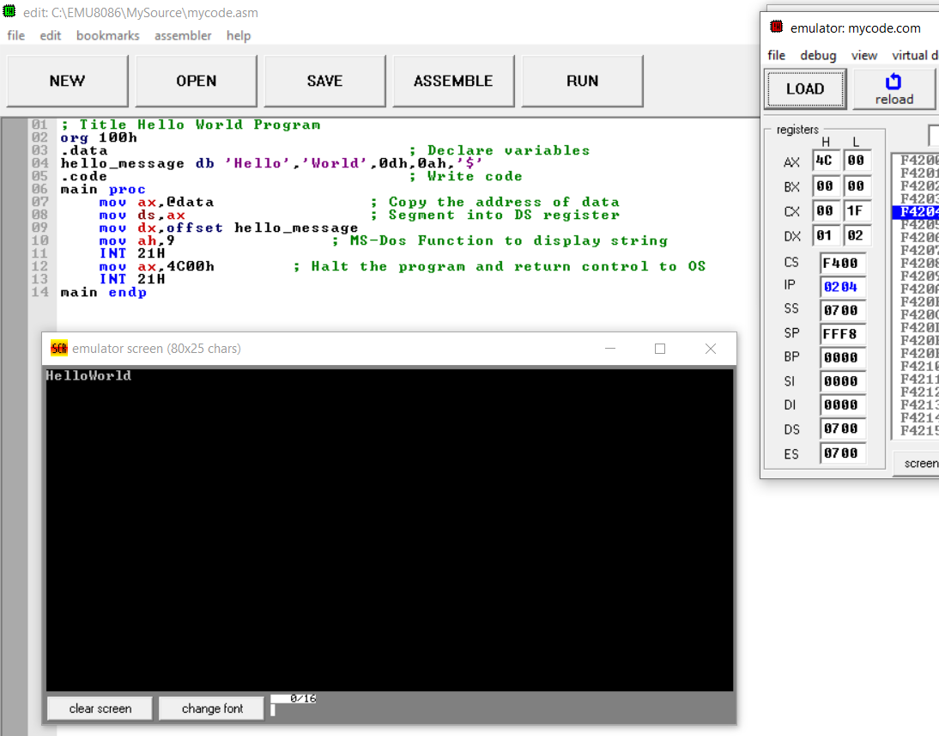

**Hello World Program 2**

**Assembly language code for vertically displaying hello world**

org 100h

mov ah, 02h ; Function to display character

mov dx, 'H' ; Display 'H'

int 21h

mov dx, 0Dh ; Move to a new line

int 21h

mov dx, 0Ah ; Move to a new line

int 21h

mov dx, 'e' ; Display 'e'

int 21h

mov dx, 0Dh ; Move to a new line

int 21h

mov dx, 0Ah ; Move to a new line

int 21h

mov dx, 'l' ; Display 'l'

int 21h

mov dx, 0Dh ; Move to a new line

int 21h

mov dx, 0Ah ; Move to a new line

int 21h

mov dx, 'l' ; Display 'l'

int 21h

mov dx, 0Dh ; Move to a new line

int 21h

mov dx, 0Ah ; Move to a new line

int 21h

mov dx, 'o' ; Display 'o'

int 21h

mov dx, 0Dh ; Move to a new line

int 21h

mov dx, 0Ah ; Move to a new line

int 21h

mov dx, 'W' ; Display 'W'

int 21h

mov dx, 0Dh ; Move to a new line

int 21h

mov dx, 0Ah ; Move to a new line

int 21h

mov dx, 'o' ; Display 'o'

int 21h

mov dx, 0Dh ; Move to a new line

int 21h

mov dx, 0Ah ; Move to a new line

int 21h

mov dx, 'r' ; Display 'r'

int 21h

mov dx, 0Dh ; Move to a new line

int 21h

mov dx, 0Ah ; Move to a new line

int 21h

mov dx, 'l' ; Display 'l'

int 21h

mov dx, 0Dh ; Move to a new line

int 21h

mov dx, 0Ah ; Move to a new line

int 21h

mov dx, 'd' ; Display 'd'

int 21h

mov dx, '$' ; End the program

int 21h

mov ah, 4Ch ; Halt the program and return control to OS

int 21h

**Output console:**

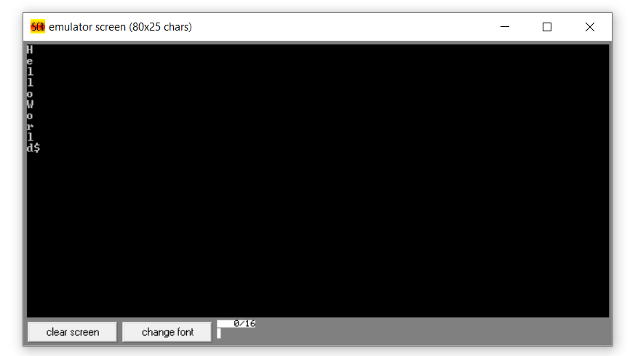

**Hello World Program 3**

**Spaced hello world**

org 100h

mov ah, 02h ; Function to display character

mov dx, 'H' ; Display 'H'

int 21h

mov dx, ' ' ; Display space

int 21h

mov dx, ' ' ; Display space

int 21h

mov dx, ' ' ; Display space

int 21h

mov dx, 'e' ; Display 'e'

int 21h

mov dx, ' ' ; Display space

int 21h

mov dx, ' ' ; Display space

int 21h

mov dx, ' ' ; Display space

int 21h

mov dx, 'l' ; Display 'l'

int 21h

mov dx, ' ' ; Display space

int 21h

mov dx, ' ' ; Display space

int 21h

mov dx, ' ' ; Display space

int 21h

mov dx, 'l' ; Display 'l'

int 21h

mov dx, ' ' ; Display space

int 21h

mov dx, ' ' ; Display space

int 21h

mov dx, ' ' ; Display space

int 21h

mov dx, 'o' ; Display 'o'

int 21h

mov dx, ' ' ; Display space

int 21h

mov dx, ' ' ; Display space

int 21h

mov dx, ' ' ; Display space

int 21h

mov dx, 'W' ; Display 'W'

int 21h

mov dx, ' ' ; Display space

int 21h

mov dx, ' ' ; Display space

int 21h

mov dx, ' ' ; Display space

int 21h

mov dx, 'o' ; Display 'o'

int 21h

mov dx, ' ' ; Display space

int 21h

mov dx, ' ' ; Display space

int 21h

mov dx, ' ' ; Display space

int 21h

mov dx, 'r' ; Display 'r'

int 21h

mov dx, ' ' ; Display space

int 21h

mov dx, ' ' ; Display space

int 21h

mov dx, ' ' ; Display space

int 21h

mov dx, 'l' ; Display 'l'

int 21h

mov dx, ' ' ; Display space

int 21h

mov dx, ' ' ; Display space

int 21h

mov dx, ' ' ; Display space

int 21h

mov dx, 'd' ; Display 'd'

int 21h

mov dx, ' ' ; Display space

int 21h

mov dx, ' ' ; Display space

int 21h

mov dx, ' ' ; Display space

int 21h

mov dx, '$' ; End the program

int 21h

mov ah, 4Ch ; Halt the program and return control to OS

int 21h

**Output console:**

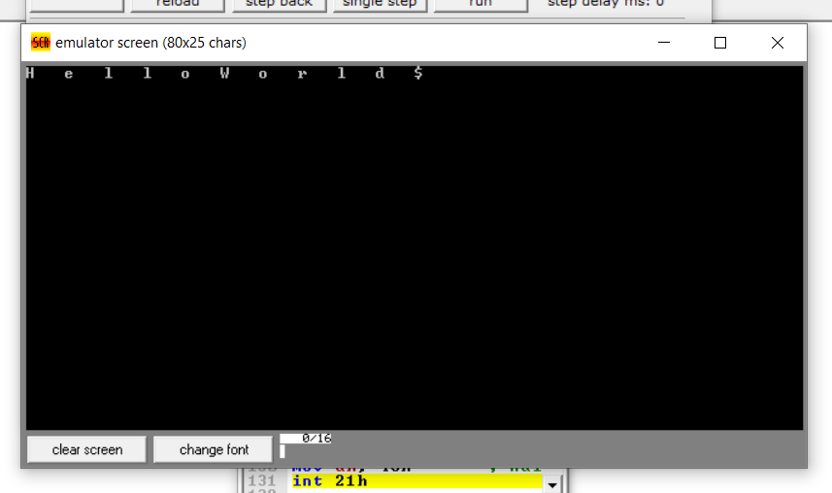

**Hello World Program 4**

**Text on two different lines**

org 100h

mov ah, 09h ; Function to display string

mov dx, offset hello_message ; Display 'Hello' on the first line

int 21h

mov dx, offset newline ; Move to a new line

int 21h

mov dx, offset world_message ; Display 'World' on the second line

int 21h

mov ah, 4Ch ; Function to exit the program

int 21h

hello_message db 'Hello$' ; 'Hello' text

world_message db 'World$' ; 'World' text

newline db 0Dh, 0Ah, '$' ; Newline characters with a terminating dollar sign

**Output Console:**

